MMA861 – Analytical Decision Making

Alfred Investment Company

Investment Portfolio Optimization



**Team Alfred**

Crystal Fang

Eddie Wang

Ekaterina Filunets

Gopala Goyal

Faiza Shallwani

Jacqueline Mak

Sushant Karmakar

Sushil Megharaj

# Introduction

Investing helps people achieve financial milestones and lead financially independent lives, even in the current pandemic. People may be financially equipped to invest but do not always have the required ‘know-how’ about the world of investing. While investing, several questions arise in one’s mind due to the diverse range of investment options and stock market volatility. Hence, investors must consider the different asset classes and the optimal asset allocation for maximum returns.

Alfred Investment Company (AIC) is an investment management company that offers investment and retirement solutions to customers. Our company helps individuals invest in a diversified portfolio of mutual funds (MF), stocks, and other financial instruments. AIC has been actively managing investment portfolios for our customers with the help of erudite advisors and portfolio managers. With the steady increase in passive portfolio management and analytics innovation, we have recently seen a rise in the need for automated tools that provide customized investment solutions. As such, we seek to implement an optimization model that will support investment managers in tailoring an investment portfolio for customers according to their risk profile and goals.

AIC’s goal is to transform the current manual process of providing investment solutions to clients. The diversification and funds allocation decisions are based on the advisor’s experience and understanding of the stock market. Combining technology-driven solutions with industry experience will help AIC deliver robust and personalized MF portfolios to its clients.

Investment management organizations understand that each client’s portfolio requires a distinctive approach. Each customers’ risk appetite, financial goals, and milestones are assessed to cater to personalized investment strategies. According to the mentioned factors, organizations build model portfolios aligned with specific risk tolerance levels. The risk tolerance levels can be categorized into “Risk Seeking,” “Risk Neutral,” and “Risk Averse.” In addition, each mutual fund’s historical performance can be analyzed to see how well it has performed. When combined with the market portfolio management experience of the advisor, this analysis can be used to develop a model portfolio that can be diversified based on a client’s risk appetite.

# Organization Background

Alfred Investment Company is a hypothetical company established to provide investment management solutions to clients with diverse backgrounds, risk appetites, and financial goals. AIC is working towards assimilating technology into portfolio management to bolster its position in the emerging investment management sector. The industry is in a very nascent stage. It is quite fragmented, thus provides a high scope for new organizations, such as AIC, to step into the space to deliver innovative solutions.

With the surge of the COVID-19 pandemic, the banking and investment management industries saw a steep decline in the brick-and-mortar infrastructure requirements. People are looking to fulfill their banking and investment needs independently from the comfort of their homes. AIC’s value proposition will be to provide investment solutions to its clients with the click of a button.

AIC provides services to people with different backgrounds and in the various stages of their lives. AIC aims to mainly target young customers as they have a high-risk tolerance and little knowledge of investing. With our low-cost ‘Almost-Zero’ brokerage and consumer-specific portfolios, AIC believes it can differentiate itself from competitors and offer extraordinary service to its customers.

Problem Statement

When investing in the world of mutual funds and the stock market, the fear of losing the initial investment is often a factor that makes customers hesitant. Since each investor has their own risk and returns profile, we need a solution that guarantees a minimum return according to individual investment profiles. Due to the customer’s limited knowledge of the stock market, the solution should break down the proportion of the investment in the defined set of available mutual funds at AIC’s retail portal. It is essential to architect a solution that would help maximize our clients’ minimum returns. Our solution should guarantee a minimum return percentage and provide estimates of the maximum possible returns for each customer. Therefore, AIC’s solution architects will design a model that helps the customer achieve maximum returns on their investment and a guaranteed minimum return as per their risk profile. The model would ease out the portfolio managers’ job to explicitly create portfolios for the entire AIC customer base.

According to the market research and our analysis of the AIC current customer base, AIC targets to handle three types of clients, “Risk Seeking,” “Risk Neutral,” and “Risk Averse.” The three types of clients differ in their investment goals due to their life stages, financial capacity, family responsibilities, investment horizons, and psychological traits. Each of these risk profiles has a certain percentage of minimum return that they expect. The model should be able to provide an estimate of portfolio diversification and the maximized minimum return.

The expected outcomes that the model would produce are as follows:

1. Calculate the proportion of money allocated for each type of mutual fund mathematically to increase the returns and consider the risk based on historical returns for a mutual fund to maximize the returns.
2. While calculating the proportions and estimated returns, the proposed model would consider the risk profiles and provide a breakdown of allocations amongst various asset classes. Compared to the current approach, there will be a significant amount of time saved, which can be utilized to research the dynamics of new funds in the market.
3. Due to the many financial instruments available in the market, the model should handle an increase in the number of fund types. It should recommend the diversification and proportions among each fund types according to the historical data and returns.
4. The model should be able to handle macroeconomic changes. For instance, if there are changes in the regulatory requirements by the government or any changes in the compliance guidelines, the model should be able to handle these with minimalistic modifications.

Solution Approach

The proposed solution for the model considers the risk that a customer can tolerate. As per the analysis, we suggest that one of the best approaches is to use Linear Programming (LP) model for an optimal solution. This approach would maximize the minimum return and quantify the allocation of the investment amount into different MF asset classes.

Currently, AIC is serving its customers through portfolio managers who have experience in creating model portfolios manually. The manual process often causes delays in acting fast on market trends and uncertainties. To avoid the missed opportunities and enhance customer experience, we introduce the LP model. The LP model would aid in creating model portfolios with the help of decision analytics technologies and reduce turnaround time.

To introduce the concept of LP, we analyzed and formulated the below steps required to achieve the expected outcome.

## Inputs

To create a minimal viable product (MVP), we determined a few broad categories of mutual funds that can be used to diversify a model portfolio. The classes we used include Large-Cap Equities (LCE), Mid-Cap Equities (MCE), Balanced Equities (BE), Balanced Funds (BF), and Fixed Income (FI). Our model aims to mimic the real-life scenarios of each of these widespread MF classes.

The expected return from a mutual fund asset class can be determined based on its historical performance. Although it is not viable to predict the future returns, we can use the past performance to estimate how the fund ‘could’ perform in the near future. To cater to this requirement, we collected the historical returns for each type of asset class and formulated them into a table (Table 1). Next, we require the minimum return that a customer is expecting according to their risk profile. We have identified and generalized the below three profiles according to the analysis of AIC’s current and potential target customer base.

Each risk profile has different characteristics relating to its risk tolerance and returns expectations. For example, the Risk Seeking customer would be John, who is willing to accept a negative return as he is a recent university graduate with no family responsibilities. Due to his profile, he has a high-risk tolerance but is also seeking high return.

Scenario

As mentioned earlier, we need to further hypothesize the possible investment scenarios that could represent the potential future returns by combining all the above five types of mutual fund asset classes. The table below highlights the historical returns for the five mutual funds over one calendar year. AIC’s portfolio managers would assume a particular combination to be a scenario (1 to 5) that could portray the investment returns over the next year.

The chance of each of the scenarios occurring is completely based on the experience of the portfolio manager. For our LP model, we have considered the probabilities to be 0.2, 0.35, 0.15, 0.2, and 0.1 for each of the five scenarios. These probabilities are used to find the optimal maximized minimal return for the customer.

Table 1 - Historic annual returns & probabilities

Decision Variables

The LP model would calculate the proportion allocation for each type of mutual fund (LCE, BE, MCE, FI, and BF) based on the constraints and inputs discussed above. These values would help us calculate the returns for each scenario and help maximize the minimum return for the customer.

Constraints

We added two constraints in the LP model. The first one was a proportion constraint, where the sum of each mutual fund allocation equals 1. The weightage associated with each of the mutual fund asset classes can be a floating-point number. The investment amount would be a proportion of the values calculated by the LP model.

The second constraint was to ensure that each scenario described above results in a minimum return as per the customer’s risk profile. The return for a particular scenario is calculated by multiplying the LP model’s investment proportion to the return for that scenario. For instance, to estimate the returns from scenario 1 (S1), we would use the below calculations:

S1 = 18.90 * LCE + 31.67 * MCE + 35.20 * BE + 7.62 * FI + 13.16 * BF  
The value calculated above would have to be greater than the minimum return based on customer’s risk profile.

Objective Function

The objective function indicates how each decision variable contributes to optimizing and maximizing the minimum return. The formula is as follows:

Maximize {0.2*S1 + 0.35*S2 + 0.15*S3+ 0.1*S4 + 0.2*S5}​ where 0.2, 0.35, 0.15, 0.1 & 0.2 are the assumed probabilities for the occurrence of different scenarios.

Assumptions & Limitations

To develop an MVP, we chose five distinct asset classes to run a model that provides insight on analytics-driven solutions for portfolio managers to craft personalized portfolios. However, incorporating a diverse set of asset classes would have helped us create more scenarios that produce a robust model similar to a real-life situation.

The data about returns for each asset class has been sourced from [Fidelity Investment Finder](https://www.fidelity.ca/fidca/en/products/investmentfinder) (*Fidelity Investment Finder*, n.d.). All the asset level returns per year are discrete and independent. This assumption has helped us estimate the potential returns on different scenarios and is the best possible historical data to build the model.

The model considers only three kinds of customer segments but can be expanded into more risk profiles. For more accurate and concise results, we could incorporate additional categories between high and medium tolerance.

The model would have to be updated and modified regularly to accommodate the changes in the financial world. For instance, we would need to constantly add new funds (industry-specific/general), check, and validate the impact of regulatory changes and factors that could lead the model not to return the best possible outcome.

Due to the volatile nature of the stock market, we cannot guarantee the returns that the LP model estimates. Understandably, this reduces the credibility of our model; however, by continuously evolving the model, we can ensure that the returns are a close approximation of the estimates. Regardless, we would caution as the uncertainty limitation remains.

The test model does not consider various other factors that impact the financial industry, such as inflation, recession, tax implications, professional fees for the service, etc.

Results

The output of the LP model estimates the maximized minimum returns for each type of customer risk profile. The below table shows the values of expected returns:



**-2% Return**

**-1% Return**

**5% Return**

|  |  |  |  |
| --- | --- | --- | --- |
| **Portfolio** | **Weight / Allocation** | | |
| LCE | 68.2% | 46.3% | 17.5% |
| MCE | 0 | 0 | 0 |
| BE | 24.6% | 20.2% | 13.8% |
| FI | 7.2% | 33.5% | 68.6% |
| BF | 0 | 0 | 0 |
| **Expected ROI (%)​** | **18.9** | **15.9 ​** | **11.5** |

The above returns present the distribution of each type of mutual fund that each investor should invest in to maximize their returns and achieve a guaranteed minimum return according to their risk appetite. The model has suggested a significant allocation of funds into large-cap equities for a high-risk tolerant customer due to the high risk-return tradeoff. In this scenario, 68.2% of the investment amount is in LCE, 24.6% in BE, and 7.2% in FI. The minimum return investor expected was -2%, but our LP model maximized this minimum return and calculated the expected return to be 18.9%.

For a medium-risk tolerant customer, the model has advised a diversified the investment into large-cap equity, balanced and fixed income. In this scenario, the proportion is 46.3% in LCE, 20.2% in BE, and 33.5% in FI. The minimum return investor expected was -1% with the distribution of investment in such a way as to reduce risk. Still, our LP model maximized this minimum return and calculated the expected return to be 15.9%.

Lastly, the model has advised balancing the proportion by investing majorly in FI with 68.6% investment followed by 13.8% of BE and 17.5% of LCE for a risk-averse customer. The minimum return investor expected was 5%, with the distribution of investment in such a way as to reduce risk. Still, our LP model maximized this minimum return and calculated the expected return to be 11%.

The output shows that the LP model answers the problem statement of architecting an analytical solution that would help maximize the minimum returns. The optimal solution can guarantee a minimum return percentage and estimate the maximum possible returns for the customers. The model also enables the portfolio managers to create portfolios for the entire AIC customer base explicitly.

Conclusion

To recap, the above presented LP model provides optimal investment strategies for AIC’s customers. We have assessed different risk profiles and devised a model that suggests robust, maximized expected returns and a guaranteed minimum return for each customer. Our model confirms the notion of higher risk resulting in higher returns.

As a way forward, we would recommend testing this model in a real-world scenario. Testing would allow us to analyze the accuracy of the asset allocation through the LP model. While testing, we may also consider and collect data on COVID-19’s impact on the stock market. After the testing process, we recommend obtaining feedback on the results and launching this analytical model. We anticipate a constant model refinement based on its performance, changes in the industry dynamics, and economic conditions. We must also account for adjustments in investor risk tolerances, as investor profiles change as they transition into different life stages.

Technical Appendix

Linear model for minimum return of -2% (Risk Tolerant) customer:

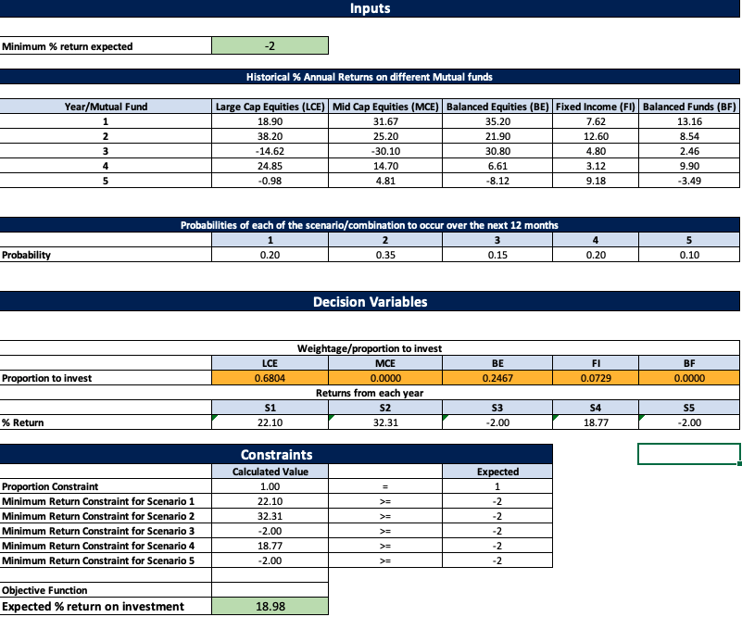

Sensitivity Report -2%

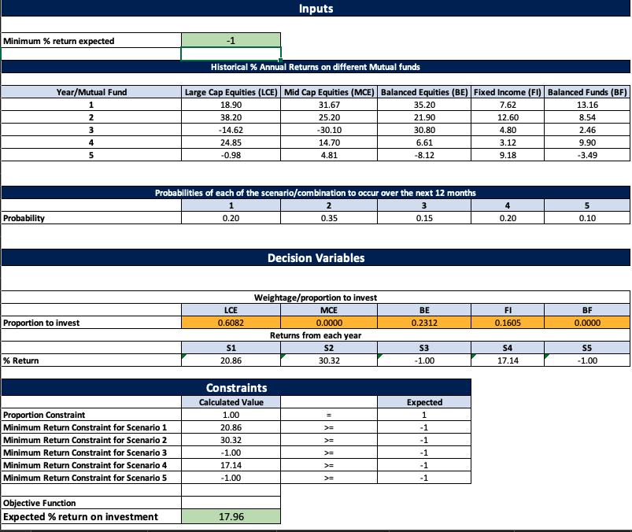Linear model for minimum return of -1% (Risk Neutral) customer:

Sensitivity report -1%

Linear model for minimum return of 5% (Risk Averse) customer: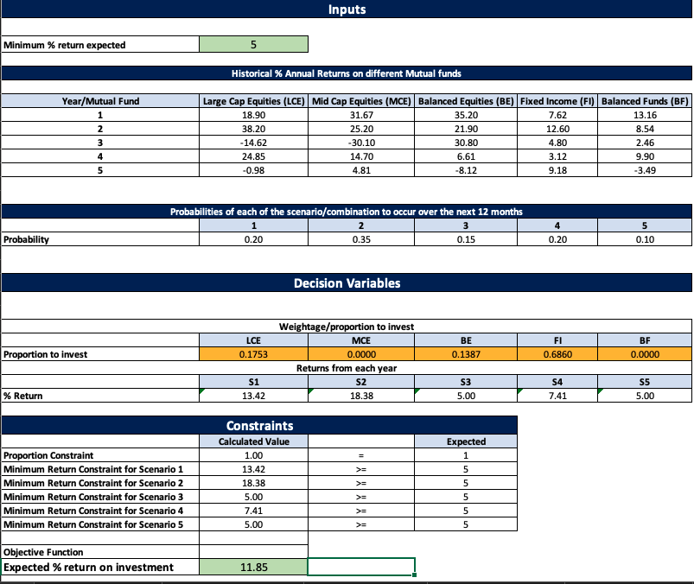

Sensitivity Report 5%

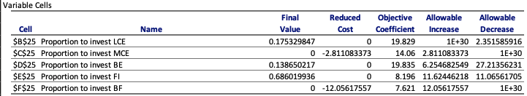

Decision Variables, Objective function and Constraints

Formulas:

References

*Fidelity Investment Finder*. (n.d.). [Company Website]. Fidelity Investments. https://www.fidelity.ca/fidca/en/products/investmentfinder